**Qubits: Function, Fabrication and quantum dots**

Chase C. Sadri

B. B. Blinov

Physics 324

**Abstract:** Serving as the essence of quantum computing – qubits can be fabricated as quantum dots (semiconductors with confining potentials), ion traps (excitable ions that respond to laser pulses and microwaves) and optical qubits (based on properties of photonic spin).   
_________________________________________________________________

**Introduction**

Modern quantum computation (QC) is dictated by the quantum parallel of classical computation’s “0 and 1” bits. Quantum bits, which hitherto shall be referred to as “qubits,” are the fundamental building blocks of quantum information technology. Similar to how bits function as the input and output of a classical logic gate, qubits make up the quantum logic gates that dictate quantum computation. However, vast differences appear when we breach the subject of **function** and **fabrication**, which will be the foci of this particular paper.

Despite lacking a complete understanding of the extent to which the power of a quantum computer might be utilized, it is becoming well known that the ability to carry out quantum algorithms has serious implications in the future of computing. One such example is Shor’s algorithm [14], who introduces a method for prime factorization in polynomial time. This alone would be enough to totally shatter modern encryption standards and it’s not only wildly exciting to consider how we’ll be forced to adapt to such drastic changes, but also consider the incredible benefits of this awesome technology.

With quantum computing being the most notable application of qubit technology, there is groundwork laid in what we require of the qubit. In terms of construction, these requirements involve: a means for state preparation, construction of quantum gates, and technology for measuring qubit’s state[2]. However, there are much more rigid standards [A] set by Loss & DiVincenzo that have held up for a number of years. Fortunately, there are several different types of qubits that we can implement depending on the nature of the problem we are trying to solve and resource availability. The most popular qubits in quantum information processing are optical qubits, ion traps, and **quantum dots**. We’ll shortly address each of these but I would like to place a precise lens over the semiconductor potential wells that are quantum dots.

**Function**

Following core principles of quantum mechanics, qubits serve as the quantum parallel to the “bit” of the classical information processing. For the purposes of this research, I feel we may benefit most from a side-by-side comparison of classical and quantum computers: where they differ, qubit advantages, and exciting quantum mechanical phenomena that are likely to find a home in quantum information processing (QIP).

The bits of classical computation are considerably linear in that they exclusively exist in one of two states “on/off.” However, this isn’t to say that we can’t accomplish greatness with a mere two states – our ability to combine a vast quantity of bits in a register and perform gating operations on one or more of them at a time allows for everything from arithmetic logic to near absolute freedom with high-level programming languages. Now, the first extraordinary QM phenomenon that we can observe in a qubit is the principle of superposition. If we are to consider classical bits as having two possible states - |0> or |1>, we can observe a quantum bit to exist in a superposition of these states such that |Ψ> = α|0> + β|1> where α and β are normalized constants (|α|2 + |β|2 = 1). Clever use of this property (such as in Shor’s algorithm [14] with the application of straightforward modulus operations to a wide superposition of states) has the potential to greatly reduce computational time associated with problems for which no polynomial-time solutions exist.

|  |  |  |  |
| --- | --- | --- | --- |
| IN1 | IN2 | IN3 | **OUT** |
| 0 | 0 | 0 | 0 |
| 0 | 0 | 1 | 1 |
| 0 | 1 | 0 | 1 |
| 0 | 1 | 1 | 0 |
| 1 | 0 | 0 | 1 |
| 1 | 0 | 1 | 0 |
| 1 | 1 | 0 | 0 |
| 1 | 1 | 1 | 1 |

The next most fundamental aspect of a bit is the way in which it is operated on and used in the pursuit of information processing. To this end, we are applying the laws of Boolean algebra on one or more input signals to obtain a single output signal 7. One popular example of classical logic comes in the form of an exclusive-or (XOR) gate, with truth table for the two and three input cases given:

|  |  |  |
| --- | --- | --- |
| IN1 | IN2 | **OUT** |
| 0 | 0 | 0 |
| 0 | 1 | 1 |
| 1 | 0 | 1 |
| 1 | 1 | 0 |

A quantum logic gate, on the other hand has a Hamiltonian associated with its transformation. Unlike classical logic gates that follow standard procedure for circuit construction, qubit gates are highly dependent on the qubit medium we’re investigating (i.e. electric field, magnetic field, optical elements, etc.). Regardless of operation, single qubit Hamiltonians serve to flip, rotate, precess or even take the quantum state in and out of superposition. Going a step further, quantum logic incorporates two qubit gates where the state of each qubit is considered in tandem, thereby allowing for previously unavailable gating operations, such as establishing one qubit as a control that determines whether or not we are to act on the other. Looking to quantum dots, we could enact this kind of operation by lowering the barrier between two QDs to take advantage of coupling [B] and tunneling effects between the two dots 8. Another exciting effect is that qubit gates preserve qubit count before/after operation; meaning we are no longer limited to classical calculations that have only a single output. An example 2-qubit gate Hamiltonian (Controlled-Not) with associated logic table is given below.

|  |  |
| --- | --- |
| |a,b> | |a, ab>* |
| |00> | |00> |
| |01> | |01> |
| |10> | |11> |
| |11> | |10> |

* where is the XOR operator

While we’re considering the XOR gate, it might be a good time to touch on the concept of entanglement [3] – a phenomenon that arises when the measurement of one particle is the sole influencer in the outcome of the second. An interesting outcome of the XOR gate is the disentanglement of an entangled state and vice versa.

With all this talk about output, you might be asking yourself, “but wait… if I can only measure a single output state, why am I messing around with all this superposition nonsense in the first place?” If that’s the case, you’ve simply forgotten all that’s happened prior to the measurement! This scenario describes wave function collapse [3] the idea that, upon measurement, any wave function superposition will collapse to the measured eigenstate and the probability of measuring that eigenstate goes to 100%. However, it’s very important to keep in mind that, while a qubit is being operated on, the principle of superposition still applies.

|Ψ>|ψn> … upon measurement of ψi collapses to… |Ψ> = |ψi>

**Fabrication**

**Optical qubits**

As an introduction to quantum computing, optical QC is an incredible starting point. Since optical qubits don’t share the extreme temperature and pressure requirements of the other qubits we’ll cover, optical quantum computers are significantly easier to design and build than other methods we’ll be covering. Casting aside the relatively straightforward means of construction, optical QIP is simpler to visualize in tandem with what we learned throughout our introduction to quantum mechanics (PHYS 225).

Similar to the stern-gerlach (SG) apparatus that fires a beam of atoms in an oven to initialize a quantum state, optical QC initializes a quantum state with a single photon source 1. It’s worth noting that deterministic photon generation and detection is quite difficult, resulting in a noticeable degree of photon loss [4]. The beam deflection achieved by a nonuniform magnetic field used in SG-experiments is, in most cases, handled by phase shifters and beam splitters [3]. In terms of our quantum network, these are the devices applying unitary transformations that serve as quantum gates. Following initialization and measurement, detection is destructively handled by photo-detectors used to read spin eigenstate. Holistically, I would consider optical qubits to serve as a powerful tool to introduce concepts of QC.

However, we run into a few difficulties when we attempt quantum computation with optical qubits. For example, photon loss that arises with teleportation is often considered a large problem. We also run into even larger problems with the implementation of two qubit gates considering the inability that photons cannot couple directly to each other and an external field without the introduction of additional particles. Finally, cumbersome designs (outside of integrated photonics) make optical quantum computers more difficult to scale and integrate than ion traps or quantum dots.

**Ion Trapping (Hyperfine)**

As it stands, ion traps (we’ll consider barium ions for introductory purposes) are a “leading contender for use as a qubit in quantum computation schemes” [5]. Using the hyperfine structure of hydrogen [3]: a model that further refines our derivation of the wave function and allowed energies by adding energy due to nucleus motion; we can obtain incredibly accurate readout of spin state. With optical quantum computing we went step-by-step and considered state preparation, gating operations, and detection. I feel it prudent to undertake a similar process so that we’ll establish a strong introductory overview of ion traps.

Prior to serious consideration of ion trap fabrication, it must be noted that these are incredibly difficult to manufacture outside of a laboratory setting. First, we must use ultra-high vacuum (UHV) to reduce noise and prevent coupling [3, B] to the environment. In general, we are implementing extremely precise lasers targeted at <100 µm wide regions to manipulate the energy eigenstate of the trapped ion. To initialize, we photoionize our barium atom to obtain an ion and then use a cooling laser to reach the ground state energy of Ba+. We have the ability to determine the initial state of our trapped ion using techniques of “quantum jumping” [7]. This technique involves targeting a polarized laser beam and counting scattered photons to determine spin state.

Following preparation, our gating operations are often achieved using microwaves or ultrafast detuned laser beam pulses to induce Rabi flopping [C]. Lastly, we require a detection method and, fortunately for us, we can accomplish this in a very similar manner to how we determined our initial state. Since we are able to determine whether a particle is in a particular spin state from photon scattering, detection primarily comes down to single-photon-sensitive cameras.

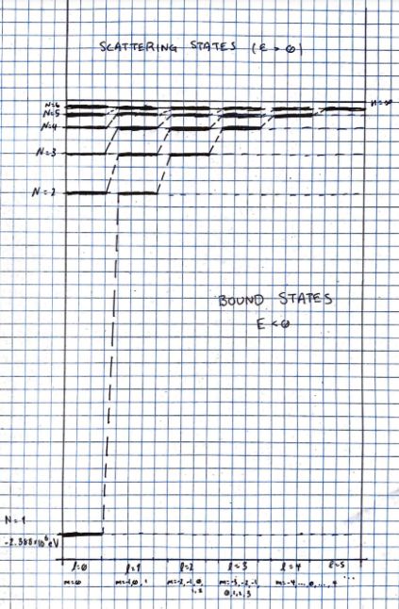[3] **Fig. 1:** Energy level diagrams for barium treated as a hydrogen-like atom (See Griffiths 5.2.2 for quantum number breakdown of Barium with (1s)2 (2s)2 (2p)6 (3s)2 (3p)6 (4s)2 (4p)6 (3d)10 (5s)2 (5p)6 (4d)10 (6s)2 ). N=1 corresponds to the ground state energy of approximately determined by treating Barium as a hydrogen-like atom. A more accurate approach would involve the following Hamiltonian in solving the Schrӧdinger equation.

However, the second summation involves terms for electron-electron interaction that aren’t easily solvable, which makes approximation methods (or emission spectrum experimentation) all but necessary.

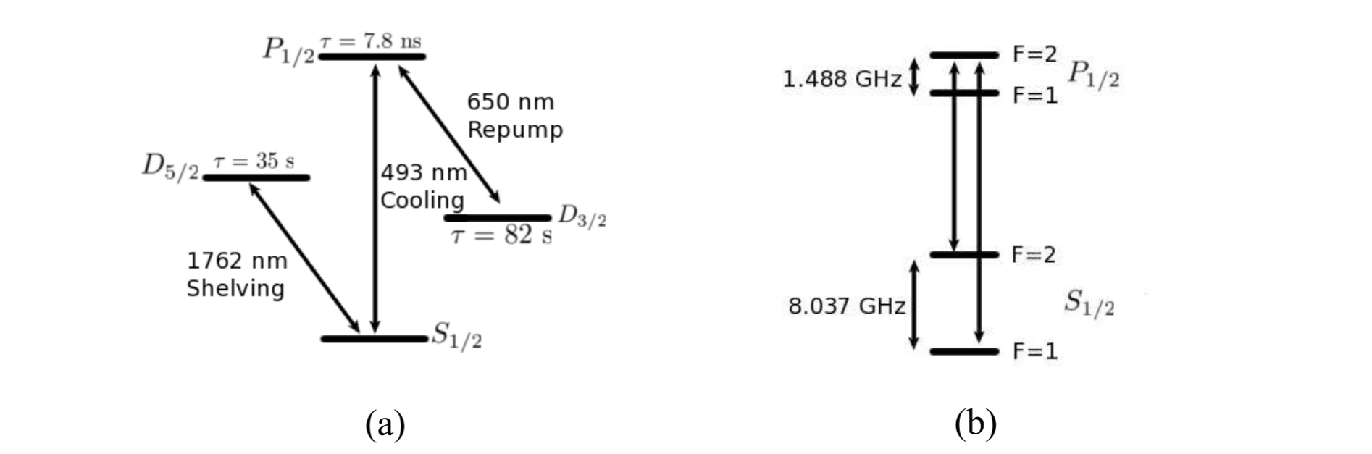

[5] **Fig. 2:** Energy level diagrams for 137Ba+ in the context of an ion trap. (a) Transition schemes involving high fidelity readout with a shelving laser and cooling to return to ground state. (b) A detailed scheme of the cooling transition displaying zeeman splitting (in GHz) between energy levels.

**Semiconductor Quantum Dots**

In my mind, any discussion of non-optical quantum dots is best introduced through the “Loss DiVincenzo Proposal” of the late ‘90s. In essence, the two gentlemen suggested that quantum computation could be achieved using existing semiconductor technology by trapping electrons in potential wells and modifying their spin states with an oscillating magnetic field.

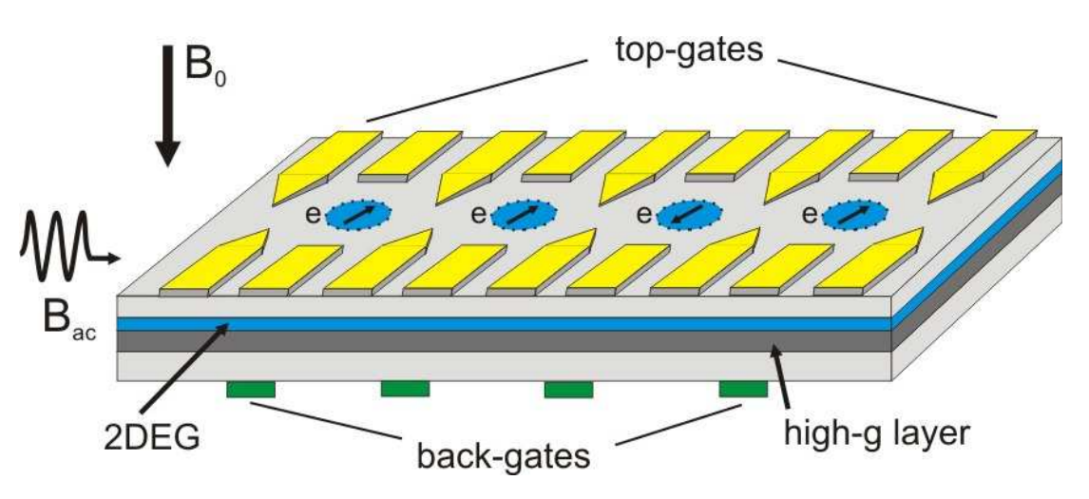

[10] **Fig. 3:** A schematic of the Loss-DiVincenzo proposal. The top gates are electrodes used to establish potential wells for trapping single electrons in the 2DEG heterostructure. Back gates pull electrons into the high-g 2 layer, thus changing their resonance frequency so they can be manipulated by the AC magnetic field.

From the top, we find ourselves applying voltages to the electrodes forming the top gates so that we can extract individual electrons from the two-dimensional electron gas (2DEG). Hence, we are left with a single electron inside of our quantum dot. Similar to the ion trap, we are forming a kind of potential well where the particle is unable to escape. For our purposes, it might be convenient to imagine a lone electron held in an infinite square or delta-function potential well [3, D]. Now that we have our scalable system of well characterized qubits, we are ready to initialize our state and to do this we will be using the concept of Zeeman energy splitting. In the presence of an external magnetic field, states that would normally be degenerate are split with an energy difference dictated by the Zeeman energy. Taking advantage of this, we cool our system to temperatures well below the Zeeman energy difference 3 to achieve ground state energy.

When it comes to qubit manipulation for a quantum register, we must keep in mind that a method for manipulating one or two qubits at a time is required for proper implementation of quantum gates. For this reason, it’s not enough to simply drive Rabi flops with an oscillating magnetic field. As one might imagine, there are complications associated with generating local magnetic fields to be applied to each individual quantum dot on a chip. As a result, we find the most promising methods of manipulation to come in the form of a global field paired with locally applied electric fields or g-factor engineering. For locally applied electric fields, we have very recently found success shifting the resonance frequencies of electrons in and out of resonance with the global field [12]. G-factor engineering on the other hand is very tricky in its utilization of the Zeeman effect. By applying back voltage, the electron can be pulled into a layer with higher g-factor so that we may selectively operate on multiple qubits at a time. Whichever method we decide to implement, we are selectively toying with the resonance conditions of single electrons and the Hamiltonian for such a rotation is given by the following [1,10]:

where is the time with which our electron’s wave function interacts with magnetic field , N is qubit count, and is the exchange interaction used for qubit coupling between site and site . The first equation only applies to a one-qubit gate while the second handles both.4

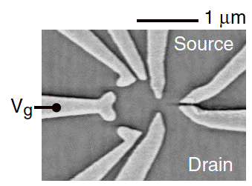

[15] **Fig. 4:** An SEM image of a quantum dot with drain, source, and top gate voltage. Electron(s) would likely be found in the circular region surrounded by gates while the quantum point contact could be found in between source and drain.

Wrapping up our introduction to quantum dots with detection methods, I would like to note that readout of electron spin state in a quantum dot is fraught with much more strain than the methods we’ve covered previously. Notwithstanding, most prevalent methods for state detection involve spin-charge conversion that is then detected by the current measured through a quantum point contact (QPC) sandwiched between the top gates and 2DEG. By changing quantum dot’s potential such that spin-up ground state is below the Fermi energy level of drain, and using our QPC to determine whether or not there is current flow, we can posit that the qubit is in the ground state if no tunnelling [D] occurs and in an excited state if there are two tunnelling events (out followed by in)

**Future Research**

On the path to a fully founded computer that benefits from the properties of quantum mechanics, we might find it worthwhile to design and build simple circuits that employ qubits. Consider, for a moment, the classical transistor AND gate that could be constructed as a circuit in the following manner with the associated truth table.

|  |  |
| --- | --- |
| IN | **OUT** |
| 0 | 1 |
| 1 | 0 |

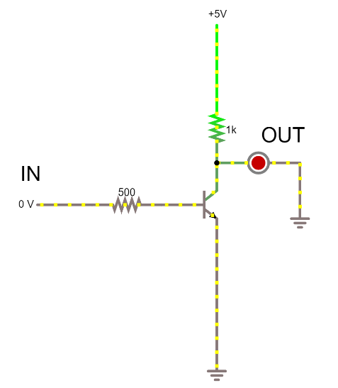

**Fig. 5:** The transistor NOT gate of classical computation. Here, we observe a single output depicted by the LED as being on or off.

Even in the case of a very simple logic gate circuit, we can learn a lot in the design of a similar circuit using qubits. Being one of the most fundamental gates in digital logic, the NOT gate is the ideal starting point for building quantum circuits. To this end, we will move forward with an example where we parallel our classical inputs of high/low voltage and transistors with qubits in a semiconductor quantum dot. In the context of SQD this requires applying a back voltage to pull a trapped electron, which will henceforth be referred to as the “bit,” into high g-layer so that Rabi flops may be induced by a magnetic field. Since a NOT gate is a straightforward spin-flip, we can induce this through the methods outlined in Addendum [C].

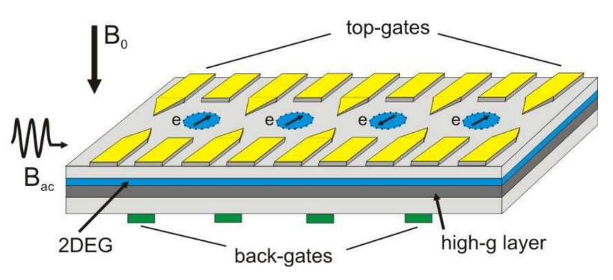**[C] Fig. 6:** A NOT gate could be realized by applying back-gate voltage and pulling a single electron into the high-g layer so that it may be influenced by Bac set to the angular frequency described in [C].

Taking it a step further, we step towards realizing the full potential of quantum computation when we begin to design and implement 2 qubit gates. Since we have the exciting new potential for logic that preserves bit count, we can begin to turn our minds to the possible circuits (like adders, registers, and flip-flops) that would play a major role in quantum computation.

**Addendum**

**A. The DiVincenzo Criteria [8]**

1. *A scalable physical system with well characterized qubits* – “The degrees of freedom required to hold data and perform computation should be available as dimensions of the Hilbert space of a quantum system.”
2. *The ability to initialize the state of the qubits to a simple fiducial state* – “It must be possible to place the quantum system in a fixed starting state.”
3. *Long relevant decoherence times, much longer than the gate operation time* – Quantum system must have decoherence time longer than operation time such that it will be “isolated from coupling to its environment”
4. *A “universal” set of quantum gates* – “It must be possible to subject the quantum system to a controlled sequence of unitary transformations x”
5. *A qubit-specific measurement capability* – A measurement that can “determine which orthogonal eigenstate of some particular Hermitian operator the quantum state belongs to, while irreversibly projecting the wave function of the system into the corresponding eigenfunction”
6. *The ability to interconvert stationary and flying qubits*
7. *The ability faithfully to transmit flying qubits between specified locations*

**B. Coupling (spin-orbit) [3]**

If we are to consider a proton spinning around an electron (in the electron’s frame of course), we would observe a magnetic field, **B**

generated by what is effectively a current loop in the form of an orbiting proton. Simultaneously considering the motion of the electron with the proton as our frame of rest, we observe angular momentum, **L**

that points in the same direction. Hence, we have…

Pairing this with the magnetic dipole moment of the electron produced by its own spin,

we find that the magnetic moment experiences a torque (τ) in the presence of an externally applied magnetic field:

As a result of this torque, we can calculate the resulting energy (in the case of a stationary proton) using the following work-torque relationship

Considering that total work done on a system is equivalent to its energy, we observe the energy of a spin-orbit coupled system to be represented by the following

**C. Rabi Flopping [9]**

As opposed to spin precession in the case of static magnetic field, Rabi flopping occurs when we impose a rotating magnetic field with angular frequency in the presence of a static magnetic field of the following form.

As a result, we observe transitions between energy eigenstates and find energy exchange between system and applied field in the form of the following Hamiltonian:

With the matrix representation:

Solving Schrodinger’s equation 5 using our newfound Hamiltonian with respect to the rotating frame of reference offers a different representation of the Hamiltonian,

where:

To solve this, we took a somewhat sneaky approach where we define the state vector with respect to each frame of reference and, using the coefficients for the stationary frame, derived coefficients for the rotating frame.

Noting probability for spin flip as the complex square of an inner product between output state and input state, we use Rabi’s formula to find a spin-flip probability of:

When we consider electron spin resonance as it applies to spin rotations in semiconductor quantum dots, we can take advantage of this property by setting equal to the larmor precession frequency of the system (we call this being on resonance) in a purely static magnetic field, our probability of spin flip becomes,

,

implying that there is 100% probability of finding the electron in spin up if the angular frequency of rotating field is set to = odd multiples of .

**D. Delta-Function Potential + Tunneling [3]**

Classically, we can begin by imagining a cart rolling on a frictionless track. If we set this cart with some kinetic energy so that it then encounters a ramp where the highest point has a potential energy above the starting kinetic energy, the cart would have no choice but to turn back. Going a step further, we want to imagine two scenarios: one where a cart encounters an infinitely powerful, impenetrable barrier and another where the cart encounters an infinitely deep well.

Quantum mechanically, we can throw away most of our classical understandings of what would occur in these scenarios. Considering the infinitely deep well, we can use Schrӧdinger equation and boundary conditions of the wave function to form solutions for bound and scattering6 states. This yields the following:

|  |  |
| --- | --- |
| **Bound State:**  This state only ever has *exactly* one bound state |  |
| **Scattering State:**  For scattering states, we find two separate cases. If we consider the particles to be coming in from ±∞, we find that they are either reflected or transmitted through the well |  |

For the barrier of infinite potential energy, it would seem nonsensical to even consider that the cart would do anything but be reflected from a classical perspective. Quantum mechanically, this isn’t quite the case. Compared to the potential well, the only noticeable difference we observe is the loss of our single bound state. Peculiarly, we still observe particles transmitted through the barrier in a phenomenon known as **tunneling**.

**Footnotes**

1. Since photons have no charge, we can’t operate on them in the same manner that we would trapped ions or quantum dot electrons. Hence the use of phase shifters and beam splitters as opposed to magnetic/electric fields.
2. x The Landé g-factor comes from precession of orbital angular momentum and spin around total angular momentum along with angular momentum conservation.
3. xx This factor is determined by material properties, atomic constants, and magnetic field strength
4. An alternative approach that yields a Hamiltonian more closely in line with what we’ve learned involves electron spin resonance (ESR) that explicitly incorporates Rabi oscillations.
5. Bound states are those with which the classical parallel would involve the cart trapped in a region where it’s energy is lower than the potential it’s placed in . A scattering state would be one where the particle comes in from and goes out to infinity .
6. Classically, these input/output signals can be considered to be applied voltages.

**References**

[1] D. Loss, D. P. DiVincenzo. Quantum Computation with Quantum Dots. *Phys. Rev. A* **57**, 120 (1998)

[2] E. Knill, R. Laflamme & G. J. Milburn. A scheme for efficient quantum computation with linear optics. *Nature* **409** 46 (2001)

[3] Griffiths, David. *Introduction to Quantum Mechanics, Third Edition*. New York, Cambridge University Press, 2018.

[4] S. Slussarenko & G.J. Pryde. Photonic quanum information processing: A concise review. *Appl. Phys. Rev.* **6** (2019)

[5] B. Blinov. Bariuw Ions for Quantum Computation. *UW Dept. of Physics* (2009)

[6] R.D. Graham & B.B. Blinov. A System for Trapping Barium Ions in a Microfabricated Surface Trap. *UW Dept. of Physics*. (2013)

[7] B. Blinov, D. Leibfried, C. Monroe, & D. J. Wineland. Quantum Computing with Trapped Ion Hyperfine Qubits. *Quantum Information Processing.* **3**, 45 (2004)

[8] D. P. DiVincenzo. The Physical Implementations of Quantum Computing (2000)

[9] McIntyre, David. *Introduction to Quantum Mechanics*. Boston, Pearson Learning Solutions, 2012.

[10] Meyer, Carola. Quantum Computing with Semiconductor Quantum Dots. *Forschungszentrum Jülich.*

[12] E. Vahapoglu. Coherent control of electron spin qubits in silicon using a global field. *UNSW Sydney, Simon Fraser University* (2021)

[13] Xin Zhang, Hai-Ou Li. Qubits based on semiconductor quantum dots. *Chin. Phys. B* **27**, 2 (2018)

[14] Shor, Peter. Polynomial-Time Algorithms for Prime Factorization and Discrete Logarithms on a Quantum Computer. *Proceedings of the 35th Annual Symposium* (1996)

[15] B. Blinov. Solid state qubits: quantum dots, phosphorus in silicon. Also, electrons on helium, and more. *PHYS 427* Lecture **14**

J. Nygard, D.H. Cobden. Quantum Dots in suspended single-wall carbon nanotubes. *Appl. Phys. Lett.* **79** 4216 (2001)